**GeometryCalculator**

Create a program that can calculate the area of two different geometry figures:

* Triangle (make research for the formula)
* Square (make research for the formula)

And can transfer degrees in radians (Rad = $\frac{π}{180}β$) where $β is your degrees$.

At the start of the program as input you must enter the type of the figure (triangle or square) and after this to enter the specified data that depends to the type of figure. Use methods to solve this task.

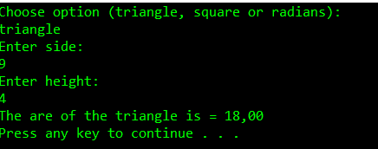

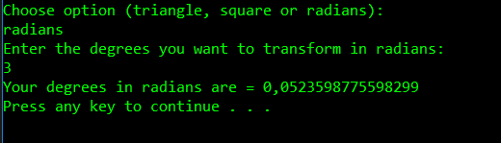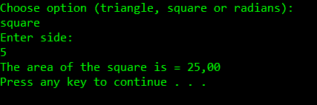

private static void triangle(double area, double side, double height)

{

area = (side * height) / 2;

Console.WriteLine("The area of the triangle is " + area);

}

private static void squer(double side, double area)

{

area = side * side;

Console.WriteLine("The area of the squer is " + area);

}

private static void radians(double β, double rand)

{

const double pi = 3.14;

rand = (pi / 180) * β;

Console.WriteLine("Your degrees in radians are " +rand);

}

static void Main(string[] args)

{

Console.WriteLine("Choose option (triangle,squear or radians)");

string choose = Console.ReadLine();

double triaside, triaheight;

Console.WriteLine("Enter side: ");

triaside = double.Parse(Console.ReadLine());

Console.WriteLine("Enter height");

triaheight = double.Parse(Console.ReadLine());

triangle(triaside, triaheight);

double squside;

Console.WriteLine("Enter side:");

squside = double.Parse(Console.ReadLine());

squer(squside);

double radians;

Console.WriteLine("Enter the degrees you want to transforma in radians:");

radians = double.Parse(Console.ReadLine());

}

switch(choose)

{

case "triangle" :

{

double triaside;

double triaheight;

Console.WriteLine("Enter side: ");

triaside = double.Parse(Console.ReadLine());

Console.WriteLine("Enter height");

triaheight = double.Parse(Console.ReadLine());

triangle(triaside, triaheight);

}

break;

case "squear":

{

double squside;

Console.WriteLine("Enter side:");

squside = double.Parse(Console.ReadLine());

squer(squside);

}

break;

case "radians":

{

double radians;

Console.WriteLine("Enter the degrees you want to transforma in radians:");

radians = double.Parse(Console.ReadLine());

radian(β);

}

break;

default: Console.WriteLine("Choose option");break;

}

Console.ReadKey();